Soft Skills

- Communication
- Self-Motivation
- Leadership
- Responsibility
- Teamwork
- Problem Solving
- Time management
- Flexibility/Adaptability
- Negotiation and Conflict Resolution
- Positive Attitude
- Strong work ethic

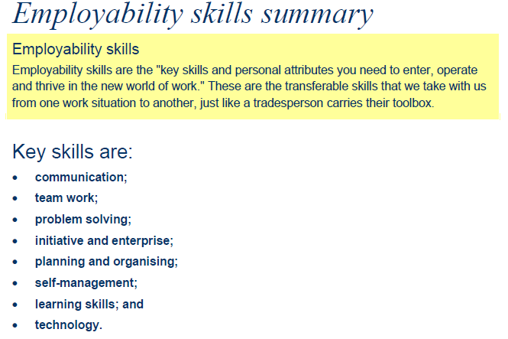

Employability Skills Framework
All young people need a set of skills and attributes that will prepare them for both employment and further learning. The Employability Skills Framework includes what employers think makes a good employee. The personal attributes and key skills are shown in the table below.

